**Mandibhav.com**

**A Minor Project Report**

Submitted To



**Chhattisgarh Swami Vivekanand Technical University**

**Bhilai, India**

For

The partial fulfillment of Degree

of

**Bachelor of Technology**

*in*

**Computer Science & Engineering**

*By*

|  |  |  |
| --- | --- | --- |
| **Harsh Singh**  **Roll No.303302218061**  **En. No. BF4753**  **Semester 7th (CSE)** | **Shirish Sahu**  **Roll No.303302218056**  **En. No. BF4748**  **Semester 7th (CSE)** | **Amrinder pal singh bains**  **Roll N0.303302218122**  **En. No. BF4814**  **Semester 7th (CSE)** |

Under the Guidance of

**Mr. Dheeraj Kumar Ghaghre**

Assistant Professor

Department of Computer Science& Engineering

S.S.I.P.M.T, Raipur

**__________________________________________________________**



**Department of Information Technology**

**Shri Shankaracharya Institute of Professional Management & Technology Raipur (C.G.)**

**Session: 2021 – 2022**

**DECLARATION BY THE CANDIDATE**

We the undersigned solemnly declare that the minor project report entitled **“*Mandibhav.com*”**is based our own work carried out during our study under the supervision of **Mr. Dheeraj Kumar Ghaghre**, **Assistant Professor**, Department of CSE, Raipur (C.G.)***.***

We assert that the statements made, and conclusions drawn are an outcome of the project work. We further declare that to the best of our knowledge and belief that the report does not contain any part of any work which has been submitted for the award of any other degree/diploma/certificate in this University/Deemed university of India or any other country.

|  |  |  |
| --- | --- | --- |
| **Harsh Singh**  **Roll No.303302218061**  **En. No. BF4753**  **Semester 7th (CSE)** | **Shirish Sahu**  **Roll No.303302218056**  **En. No. BF4748**  **Semester 7th (CSE)** | **Amrinder pal singh bais**  **Roll N0.303302218122**  **En. No. BF4814**  **Semester 7th (CSE)** |

(Signature of the Supervisor)

**Mr. Dheeraj Kumar Ghaghre**

Asst. Professor, Dept. of Computer Science & Engineering

S.S.I.P.M.T

Raipur (C.G.)

**CERTIFICATE BY THE SUPERVISOR**

This is to certify that the minor project report entitled **“*manndibhav.com*”** is a record of project work carried out under my guidance and supervision for the fulfillment of the award of degree of Bachelor of Engineering in the faculty of Information Technology of Chhattisgarh Swami Vivekananda Technical University, Bhilai (C.G.) India.

To the best of my knowledge and belief the report

1. Embodies the work of the candidate himself
2. Has duly been completed
3. Fulfills the partial requirement of the ordinance relating to the B.E. degree of the University
4. Is up to the desired standard both in respect of contents and language for being referred to the examiners.

__________________________

(Signature of the Supervisor)

**Mr. Dheeraj Kumar Ghaghre**

Asst. Professor, Dept. of Computer Science & Engineering

S.S.I.P.M.T, Raipur (C.G.)

Forwarded to Chhattisgarh Swami Vivekanand Technical University

Bhilai

___________________________

(Signature of HOD)

**Mr. J P Patra**

Dept. of Computer Science & Engineering

S.S.I.P.M.T

Raipur, C.G

_______________________________

(Signature of the Principal)

**Dr. Alok Kumar Jain**

S.S.I.P.M.T

Raipur, C.G

**CERTIFICATE BY THE EXAMINERS**

The project report entitled **“*mandibhav.com”*** has been examined by the undersigned as a part of the examination of Bachelor of Engineering in the faculty of Information Technology of Chhattisgarh Swami Vivekananda Technical University, Bhili.

__________________ __________________

**Internal Examiner External Examiner**

**Date: Date:**

**Acknowledgement**

Working for this project has been a great experience for us. There were moments of anxiety when we could not solve a problem for the several days. But we have enjoyed every bit of process and are thankful to all people associated with us during this period we convey our sincere thanks to our project guide **Mr. Dheeraj Kumar Ghaghre** for providing me all sorts of facilities. His support and guidance helped us to carry out the project. We owe a great dept. of his gratitude for his constant advice, support, cooperation & encouragement throughout the project we would also like to express our deep gratitude to respected **Mr. J P Patra** (Head of Department) for his ever helping and support. We also pay special thanks for his helpful solution and comments enriched by his experience, which improved our ideas for betterment of the project. We would also like to express our deep gratitude to respected **Dr. Alok Kumar Jain** (Principal) and college management for providing an educational ambience. It will be our pleasure to acknowledge, utmost cooperation and valuable suggestions from time to time given by our staff members of our department, to whom we owe our entire computer knowledge and also we would like to thank all those persons who have directly or indirectly helped us by providing books and computer peripherals and other necessary amenities which helped us in the development of this project which would otherwise haven’t been possible.

|  |  |  |
| --- | --- | --- |
| **Harsh Singh**  **Roll No.303302218061**  **En. No. BF4753**  **Semester 7th (CSE)** | **Shirish Sahu**  **Roll No.303302218056**  **En. No. BF4748**  **Semester 7th (CSE)** | **Amrinder pal singh bains**  **Roll N0.303302218122**  **En. No. BF4814**  **Semester 7th (CSE)** |

**List of Abbreviations**

|  |  |
| --- | --- |
| E-Commerce | Electronic – Commerce |
| DOM | Document Object Model |
| SDLC | Software Development Life Cycle |
| OS | Operating System |

**LIST OF FIGURES**

|  |  |  |  |
| --- | --- | --- | --- |
| **Sr. No.** | **Figure No.** | **Description** | **Page No.** |
| 1 | Fig. 5.1 | Process flow diagram | 10 |
| 2 | Fig. 5.2. | Described flow of data in user side | 11 |
| 3 | Fig. 5.2 | Described flow of data in admin side | 11 |
| 4 | Fig. 5.3 | Database | 12 |
| 22 | Fig. 6.1 | Iterative model working | 14 |
| 23 | Fig. 8.1 | Services of subsystem | 14 |
| 24 | Fig. 9.1 | Index page | 23 |
| 25 | Fig. 9.2 | Vegetable view page | 24 |
| 26 | Fig. 9.3 | Vegetable details page | 24 |
| 27 | Fig. 9.4 | About us page | 25 |
| 28 | Fig. 9.5 | LogIn & SignUp page | 26 |
| 29 | Fig. 14.1 | Pert chart of module completion | 52 |

**TABLE OF CONTENTS**

|  |  |  |
| --- | --- | --- |
| **Chapter** | **Title** | **Page No.** |
|  | Abstract | vii |
| 1 | Introduction | 1 |
| 1.1 | Overview | 1 |
| 1.2 | Problem statement | 1 |
| 1.3 | Approach | 1 |
| 1.4 | Benefits | 2 |
| 1.5 | Application area | 2 |
| 1.6 | Features | 2 |
| 2 | System analysis | 3 |
| 2.1 | Identification of need | 4 |
| 2.2 | Preliminary investigation | 4 |
| 3 | Feasibility study | 5 |
| 3.1 | Technical feasibility | 5 |
| 3.2 | Operation feasibility | 6 |
| 4 | Literature review | 8 |
| 5 | Analysis | 9 |
| 5.1 | Process flow diagram | 10 |
| 5.2 | Data flow diagram | 11 |
| 5.3 | Database structures | 12 |
| 6 | Software engineering paradigm | 13 |
| 7 | Software and hardware requirement specification | 15 |
| 7.1 | Software requirement | 16 |
| 7.2 | Hardware requirement | 17 |
| 8 | System design | 18 |
| 8.1 | Module description | 21 |
| 9 | Screenshots | 22 |
| 10 | Coding | 27 |
| 10.1 | Backend code/AI algorithms | 28 |
| 10.2 | Frontend code | 31 |
| 11 | Implementation and maintenance | 34 |
| 11.1 | Implementation | 35 |
| 11.2 | Maintenance | 36 |
| 12 | Testing | 37 |
| 13 | System security measures | 39 |
| 14 | Pert chart | 41 |
| 15 | Conclusion and future scope | 43 |
| 16 | References | 45 |

**ABSTRACT**

A vegetable market is a type of building or structure created and designed in various colors, materials, shapes, sizes, and styles with accurate and specific fruit and vegetables. Vegetable markets provide healthier food items that are fresher than the ones available in supermarkets.

This webpage is providing exact information about vegetable market status to consumer and producer. That is provided a pricelist of vegetable that helps to former to get great price of by their produces. And that is help to development of former.

We can also get a price list of vegetables and its consuming details of vegetables. With all data of the price, we can predict the vegetables price. That is helps to all peoples.

**Chapter 1**

**INTRODUCTION**

* 1. **Overview**

Time and money saving things grows in a fast way. This is the most common factor for any individual, organization or country. This is the reason why e-commerce industry growing day by day with high efficiency. A vegetable market is a type of building or structure created and designed in various colors, materials, shapes, sizes, and styles with accurate and specific fruit and vegetables. Vegetable markets provide healthier food items that are fresher than the ones available in supermarkets.

This project is also based on e-commerce platform, but this platform is designed for former and rural development area people by keeping in mind the requirements and issues of rural area people. For facing a problem to sell produces.

Nowadays e-commerce platforms are giving very beneficial services like to sell their produce, with best price, the people of urban areas are very comfortable by utilizing these services, and it is very common to them. For rural area people it is somewhere different, they hesitating to go market and selling their regular price.

* 1. **Problem Statement**

Weak infrastructures in rural areas are big problems for e-commerce industries to run village level facilities. Going through the rural area people they have the mindset and also they do not have any idea to sell their produces. Should come from their desired local market. They think that it will give them full control on what they are selling and get a great price by their produces

* 1. **Approach**

It is a good approach to solve the problems of rural people and motivate them towards online method and great price of their produce. From where they can facilitate the online check the price list of produces. The all markets should have the facilities like produces listing, price management, consuming produces, user management, predict the item or vegetable price and consuming etc. This site (MANDIBHAV.COM) is providing all the information of markets details and produce, prices and consuming etc.

* 1. **Benefits**

The all former are facing the problem to sell their produces. To this site (MANDIBHAV.COM) is provide a information about market and produces and its uses quantity and its price. That is collect all data of vegetable and its price with their consume quantity. By this site the former get a best price and group the development of former.

* 1. **Application Area**

Formers have some issues about selling their produces. So this site is more help full for former and rural development area. Buying and selling things are somewhere different for rural and urban area people, so we are creating a rural area e commerce platform to fulfill the demands of a rural environment.

To know the price status of vegetable markets .The rural public is the end user of this platform.

* 1. **Features**
* Having different features for different service location, it changes itself dynamically according to the user location.
* Provide the location of vegetable markets.
* Status of vegetable market.
* Price list of all vegetables.
* Consume details of vegetables.
* Store 5 day details of vegetables.
* Provide predict the price of vegetables.
* Provide information about market and vegetables.

**Chapter 2**

**SYSTEM ANALYSIS**

**2.1 Identification of Need**

Farmers markets can offer farmers increased profit over selling to wholesalers, food processors, or large grocery firms .provide a profit and provide a information about the

Vegetable markets.

In the modern trend of online and e-commerce, the rural area people are hesitating to information of market and sell and buy price of vegetables. And sell their produce to regular price.

We have identified that the rural area people also want to use modern facilities, but first of all they that running in front of their eyes. It means, they want the facilities running in their local areas.

The formers also want to reach more and more people. To establish a good connection between consumer and business (markets) a full feature platform is required according to requirement of consumer and business (markets) from where consumer can see the produces, manage their addresses, to provide information of market.

**2.2 Preliminary Investigation**

While going through online markets details aspects for rural area people, they simply want a trusted and easy to use platform. They want to understand the flows of activities being run when they get the price list of vegetables. They indicate us that the platform should transparent enough so that they can see everything related to those markets.

Final findings suggest developing this kind of platform which has the required features according to the consumer and business (vegetables markets) needs in rural area.

**Chapter 3**

**FEASIBILITY STUDY**

**3.1 Technical Feasibility**

The resources / technologies which we are using in this project are more than enough to handle the large amount of user requests and database requests. Node js is used to handle the user requests as well as to communicate with the server to send and retrieve data according to user need. MySQL is used to store the data in database, which is capable to store large amount of user data efficiently.

**3.1 Operational Feasibility**

The platform will run smoothly in any js supported server which have Node js or greater. The database, which we are using in this site, is capable of handling big amount of user data. We are using MySQL.

The site will be hosted in a server and a domain name will be selected by the Admin. With the help of domain name they will be able to use this platform. Admin will manage the produces listing, price details etc. by their admin panel.

**Chapter 4**

**LITRATURE REVIEW**

Internet is good enough to operate any e-commerce site in any area and also suggests that electricity and internet should always be available in all gram panchayat and all government sectors in rural area .In rural area the contents of any services should be available on local language so that rural area people can also understand the features of that platform.

Government policies are helping the e-commerce activities. The activities are also promoting in rural areas with help of education, all time electricity supply, mobile phones and required internet facilities. In rural area there is issue of infrastructure for the consumers, because consumers are sited in scattered areas, which needs extra information about the produces and also there demand in rural areas as compared to urban area. It also states that all the required facilities will be available to the rural area which will help the e-commerce sector to run smoothly and the e-commerce industry can grab the large potential of customers from rural area.

Public markets are located in and/or create a public space in the community. This is the visible aspect of a market – the creation of an inviting, safe, and lively place that attracts a wide range of people. As an effective place where people mix, public markets can become the heart and soul of a community, its common ground, a place where people interact easily, and a setting where other community activities take place.

Efficient transportation, handling, storage and marketing of these large amount of vegetable produces nationwide, is a tremendous challenge for vegetable markets. In order to carry out the function systematically and efficiently, plans and policies regarding vegetable market needs to be formulated, which should address various present day issues sufficiently.

This project is also based on e-commerce platform, but this platform is designed for former and rural development area people by keeping in mind the requirements and issues of rural area people. Mobile phones and digital devices will play major role in e-commerce platforms and sectors. It helps to globalize the world and serve all the facilities to all the people. But as according to the increasing quantity of digital devices, e-commerce platforms are not increasing.

Agricultural produce such as vegetables and fruits are usually mobilized through various types of marketing channels. So it is very important to define the types of marketing channels, their linkages and functions, in order to make any effective interventions in a marketing system. The rural-urban linkage in market is generally facilitated by various a networks of market intermediaries usually consisting of: farmers selling directly in market, petty traders and assemblers, wholesalers/ semi-wholesalers, commission agents/auctioneers/ brokers, transporters/ transport agents.

This site (MANDIBHAV.COM) is improving the direct selling works. By the information of markets details.

**Chapter 5**

**ANALYSIS**

**5.1 Process Flow Diagram**

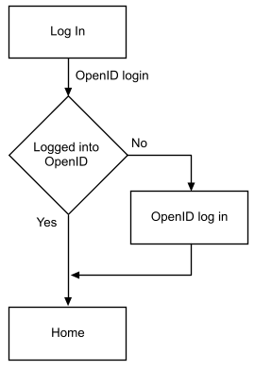

**Fig. 5.1 Process flow diagram**

The Fig. 5.1 shows the process flow and activity screens of the project. To use the platform user or customer needs to login or signup. They have provide the fundamentals information like name, mobile number, gender, date of birth, service location, passwords etc to create user account on this platform.

After successfully creation of account user needs to sign in into platform using their mobile number and password. We have provided one time login facility where user can check remember me box to stay logged in for a month till they haven’t clicked logout button.

Entered credentials for login will be checked and validated through existing data available in database. The password will be incremented through md5 and sha1 encryption techniques. On successful validation user will be forwarded to home page.

Home page has category listings, important links for profile page, about page feedback page, cart page search bar etc. By clicking any of the categories, the user will be taken to product listing page which has product name, pricing discount and image. User can search for any products from the search bar available on top navigation bar.

Product description page has full details about the products with the action buttons like buy now and add to cart. This page will show you the pricing tag, offers running for that products, delivery details, return policy etc. If the buy now button clicked, then address interface will be opened where user will have to provide their delivery address. After filling all the required information user will click to place order button.

Now order will be placed and bill will be generated. User can see the ordered products on their profile page. They can cancel the product anytime.

**Admin Side:-**

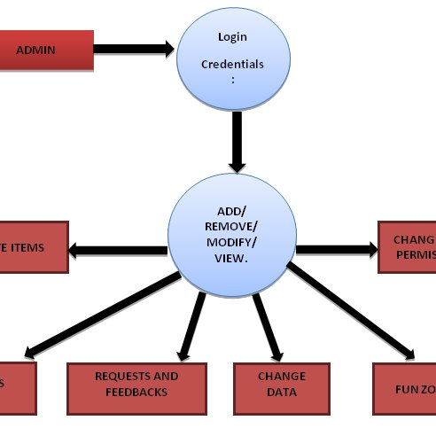

**Fig. 5.2. Described flow of data in admin side**

Admin has the facilities as shown in fig. 5.2.Admin will have to login on their panel. On successful validation, admin will be able to use the above displayed functionalities.

**5.3 Database Structures**

Database Name: mandibhav

Collation: utf8_general_ci, utf8_unicode_ci, latin1_swedish_ci

Tables Used: 15-16 (approx)

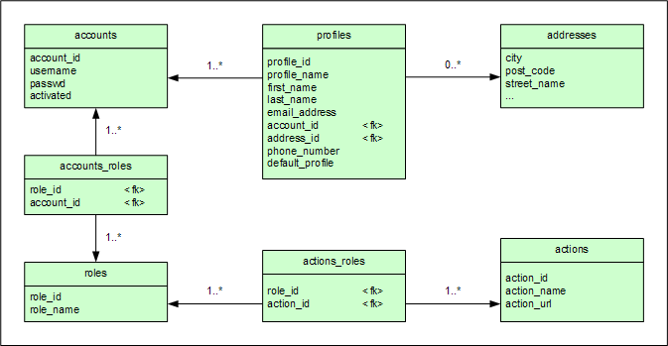

**Fig. 5.3 Database**

**Fig. 5.3 is showing the database name mandibhav**

**Chapter 6**

**SOFTWARE ENGINEERING PARADIGM**

This project is build using Iterative software development model. Iterative model helps to get started the project without having full requirement documentation. The requirement can be accepted at the any phase of development cycle (requirement analysis, design, coding, testing).

In iterative model, the requirements are accepted at any time and separately SDLC cycle applied for each requirement.

**Advantages:**

* Some of functionality can be developed quickly.
* Development can be done parallel.
* Progress can be measured according to development of each requirement.
* Testing things got easier because of separate modules.
* The highly risky requirements are completed first to avoid errors from the program.
* It is less costly to change or jump on other development phase.
* This is a good model for large and mission specific tasks.

**Disadvantages:**

* Resource engagement will high because of different - different requirements being developed simultaneously.
* It is not suitable for smaller projects.
* Module or development phase management is required to complete the project smoothly.

**Fig. 6.1 Iterative model working**

The fig. 6.1 is showing the work process of iterative model. The SDLC are separated with each increment of new requirement. Here different requirements are completing with different module in each SDLC process.

**Chapter 7**

**SOFTWARE & HARDWARE REQUIREMENT SPECIFICATION**

**7.1 Software Requirement**

**Developer Requirements:**

* Text editor (Exa. Notepad++ v8.1.2)
* Browser (Exa. Chrome v95.0.4638.54)
* JS supported server (Exa. XAMPP Server v3.2.2)

**Backend Technologies:**

* Node js
* MySQL(v5.0.11)
* JQueryAJAX(v3.5.1)

**Frontend Technologies:**

* Bootstrap(v4)
* HTML(v5)
* CSS(v3)
* JAVA SCRIPT

**Client Requirements:**

* Browser (Exa. Chrome v95.0.4638.54) with internet connectivity.

**7.2 Hardware Requirement**

**Developer Requirements:**

A fundamental setup of computer system with these key requirements-

* Processor: Minimum 1 GHz is required
* Ethernet connection (LAN) or a wireless adapter (Wi-Fi) for internet connection.
* Hard Drive: Minimum 32 GB required
* Memory (RAM): Minimum 1 GB to run smoothly.
* Other components like Monitor, Keyboard, and Mouse etc.

**Client Requirements:**

A fundamental setup of computer system or mobile phone with these key requirements-

* Processor: Minimum 1 GHz is required
* Ethernet connection (LAN) or a wireless adapter (Wi-Fi) for internet connection.
* Hard Drive: Minimum 32 GB require
* Memory (RAM): Minimum 1 GB to run smoothly.
* Other components like Monitor, Keyboard, and Mouse etc.

**Chapter 8**

**SYSTEM DESIGN**

This project has been designed with four sub systems:

1. User
2. Vegetable details
3. Admin Panel

At least three subsystems of them that is User, Product details and Admin Panel are required to run the whole system.

Shows the subsystems of the project .These four components contain multiple modules. Each Subsystem is designed with the help of some modules to run the subsystem smoothly. Modules contain some number of node js , html, js and css files.

**8.1 Module Description**

**About Module:**

About module contains developer derails page of the project. It has brief description if developer and links to reach the developer.

**Admin Module:**

Admin Module also contains multiple modules to run the admin subsystem smoothly.

**Area Module:**

Area module contains the service location control for the vegetables markets. With the help this module admin can insert new service location and can edit the service location and can delete the same. It will immediately reflect to the user side.

**Feedback Module:**

It shows the user feedback from user side for taking acknowledgement.

**Login Module:**

It contains login page and logout page. It will provide a page for login to the admin and validates the admin that it is a admin only.

.

**Price Module:**

Provide a great price of produces, former can get a good amount of their produces. That is a good thing for formers.

**Vegetable details:**

With the help of this module admin can list the vegetable and edit the vegetables details. Admin can delete the vegetables details and its information or change the price and its consuming parts.

**User Module:**

User module contains user details along with password change request. Admin can update the password for users or can delete the users.

**Control Module:**

It contains database connection code and admin credential validation code for each page.

**Feedback Module:**

This module helps the user to place a report or give a suggestion to the shop owner.

**Login Module:**

Login module has login and signup pages. User will be taken to the signup page on very first entry. After signup user data will be inserted to the database and validation process will start immediately after login on the platform. The validation code is available on control module which helps to identify the users and check their entered credentials on each page.

**Chat board:**

In these friendly discussion spots, members are able to view posts, post new queries respond to existing queries posted by other members.

Inside a forum, every new discussion started is known as a thread. There is no restriction on how many messages can be posted under each thread. In this massage board is very helpful l all the seller and buyer. And also former are get a good price of their produces.

**Index Module:**

This is the home page of the platform. After Signup-login and validation user will be taken to the home page. From here user can explore all the other modules.

**Chapter 9**

**SCREENSHOTS**

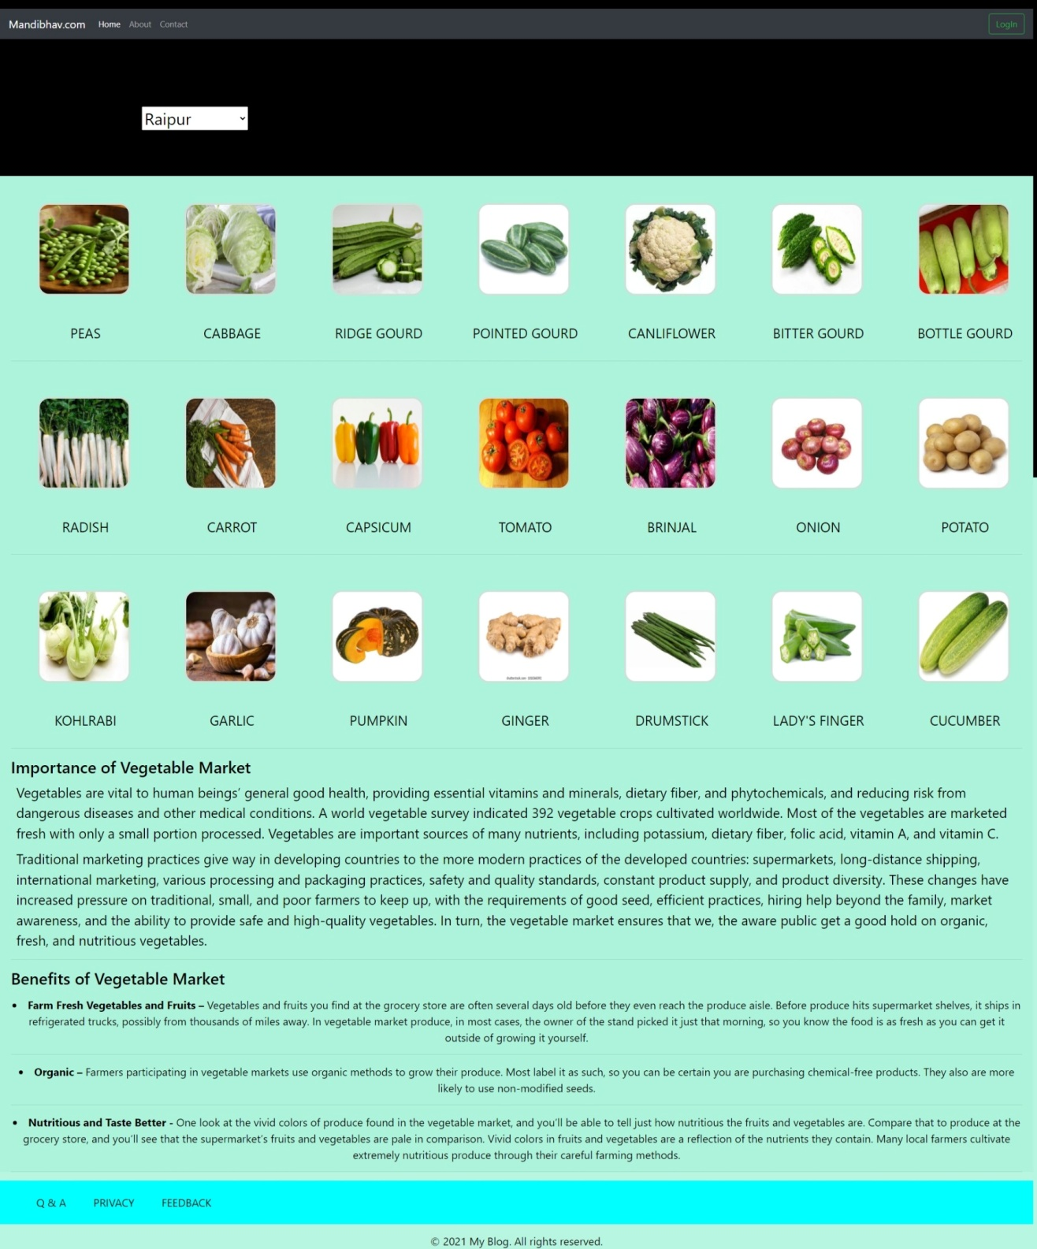

**Fig. 9.1 Index page**

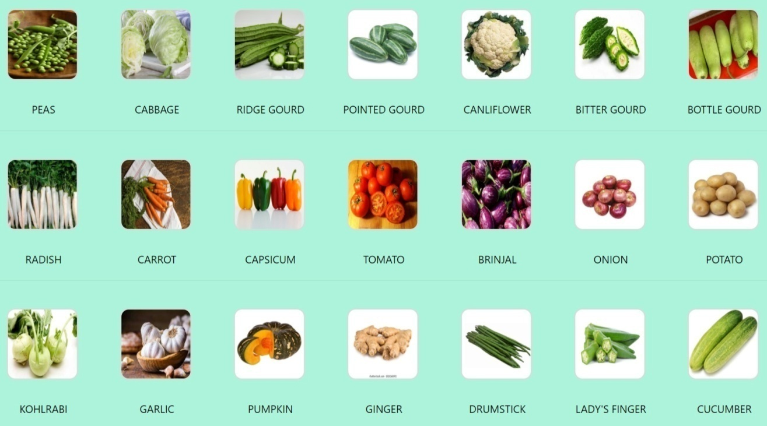

**Fig. 9.3 vegetable view page**

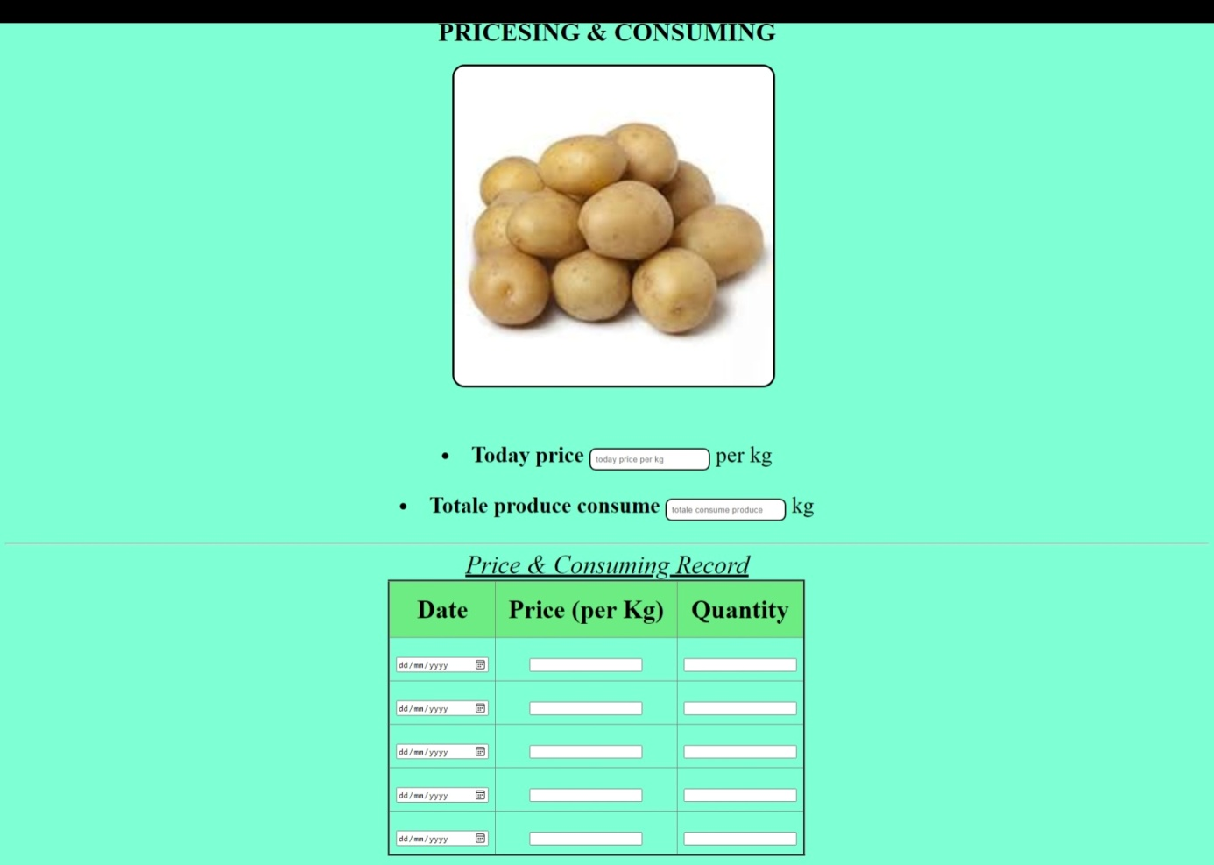

**Fig. 9.3 vegetable details page**

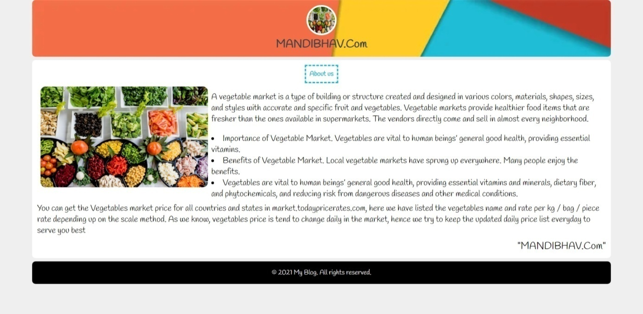

**Fig. 9.4 About Us page**

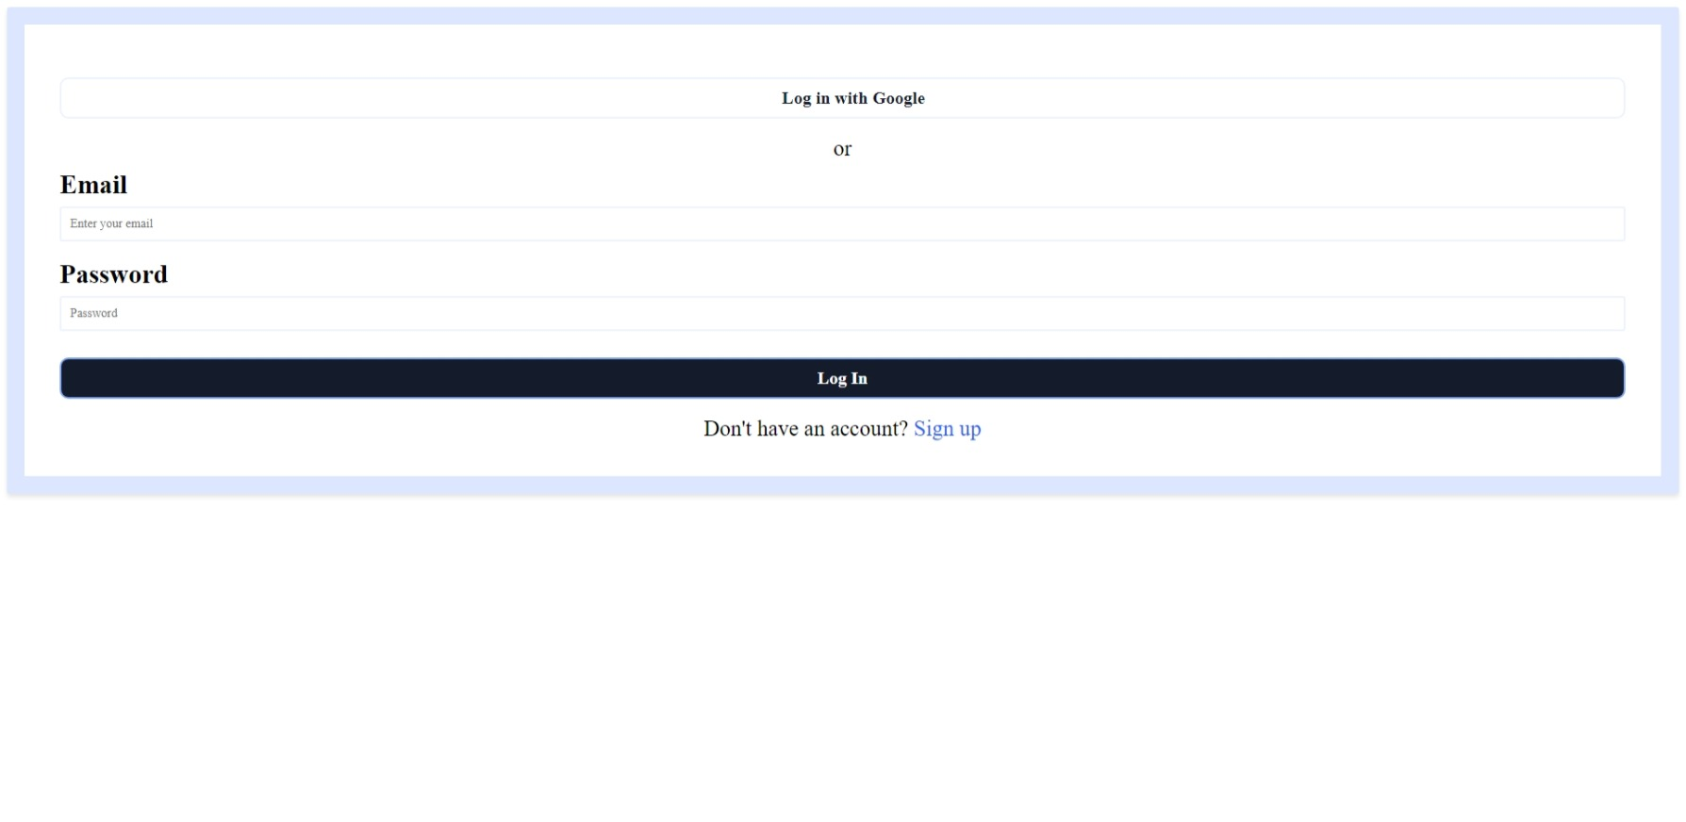

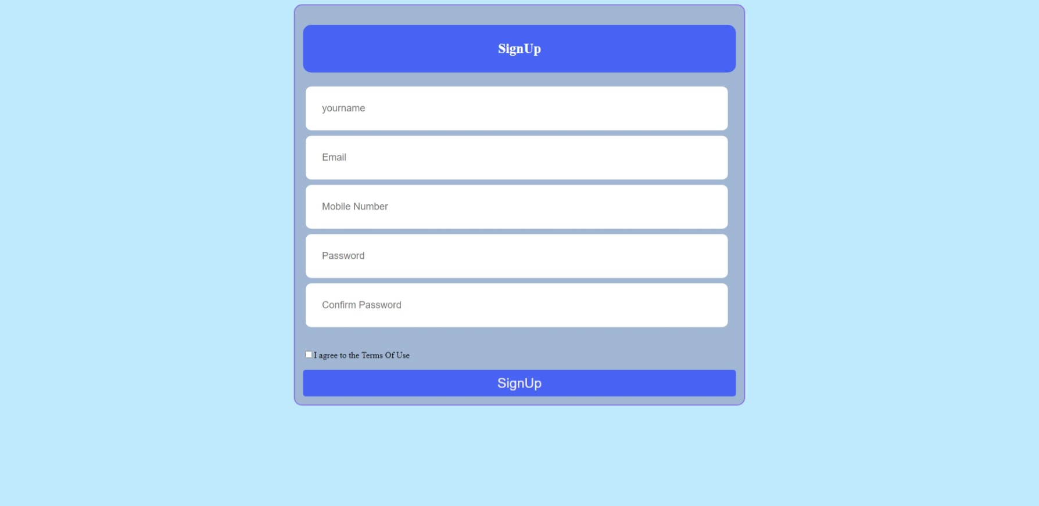

**Fig. 9.5 Login and Signup page**

**Chapter 10**

**CODING**

**10.1 Backend Code and AI**

These are the backend code :

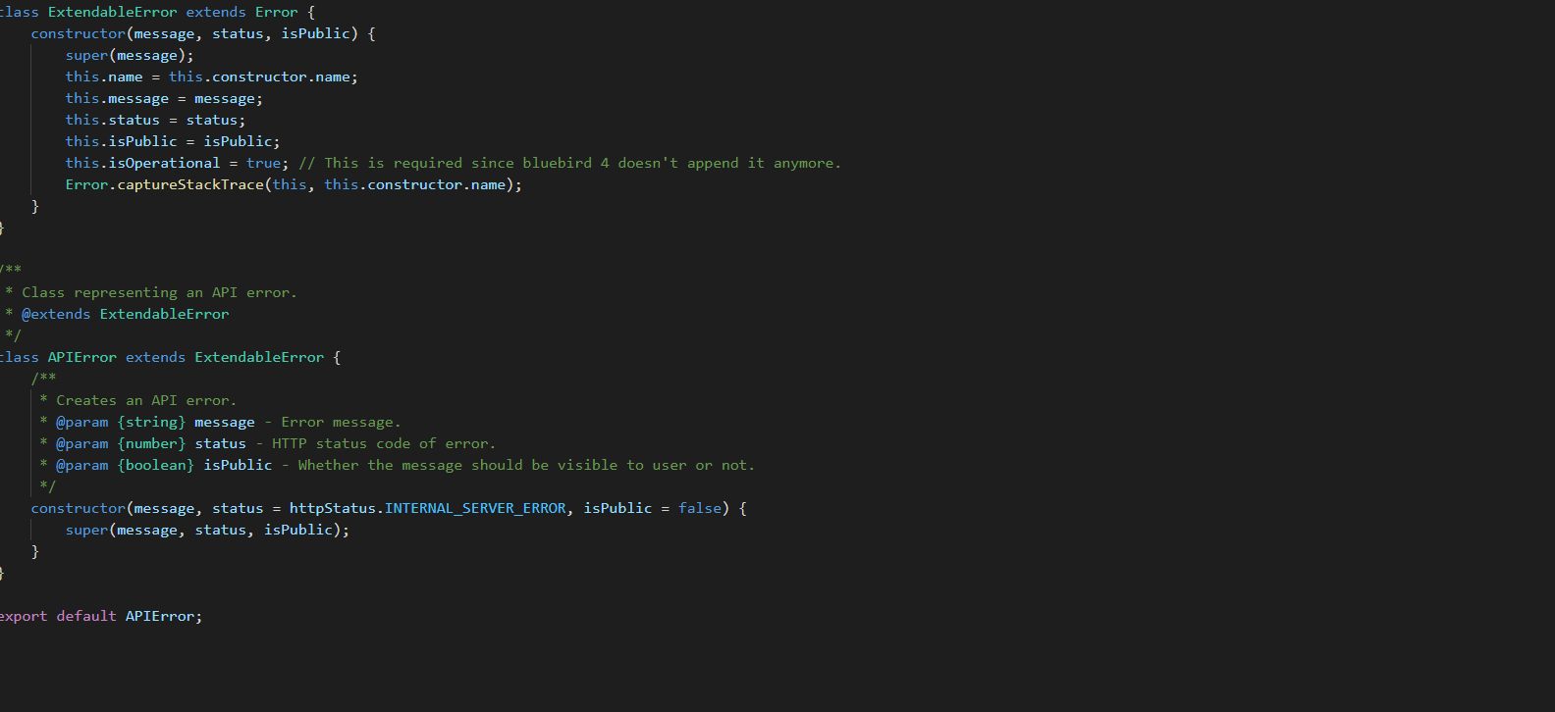

**Fig : backend API code**

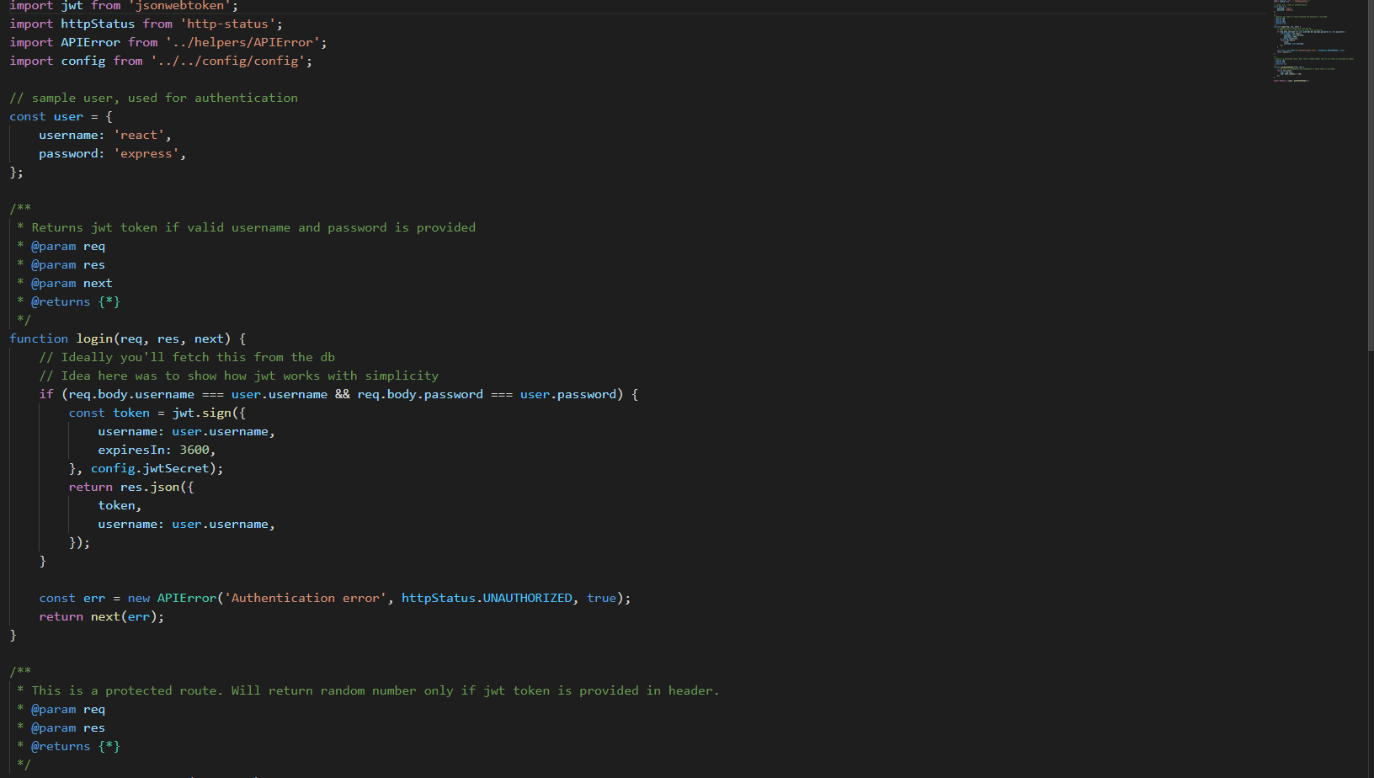i

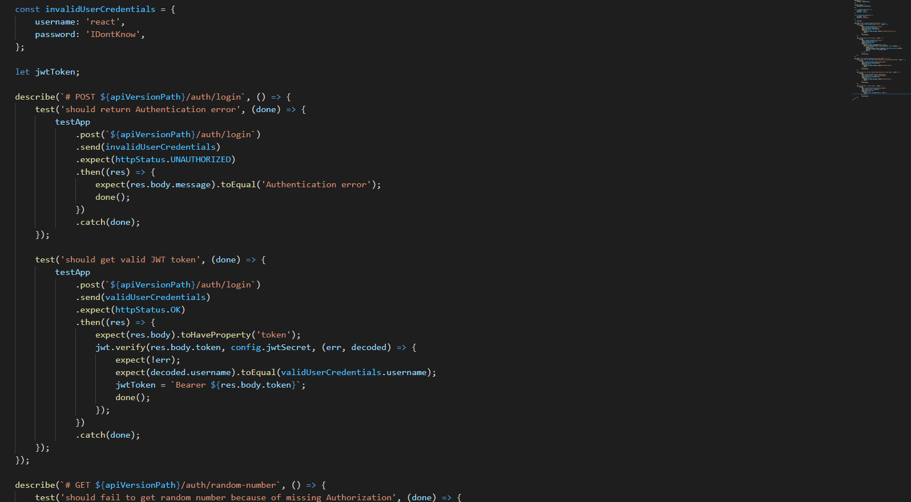f

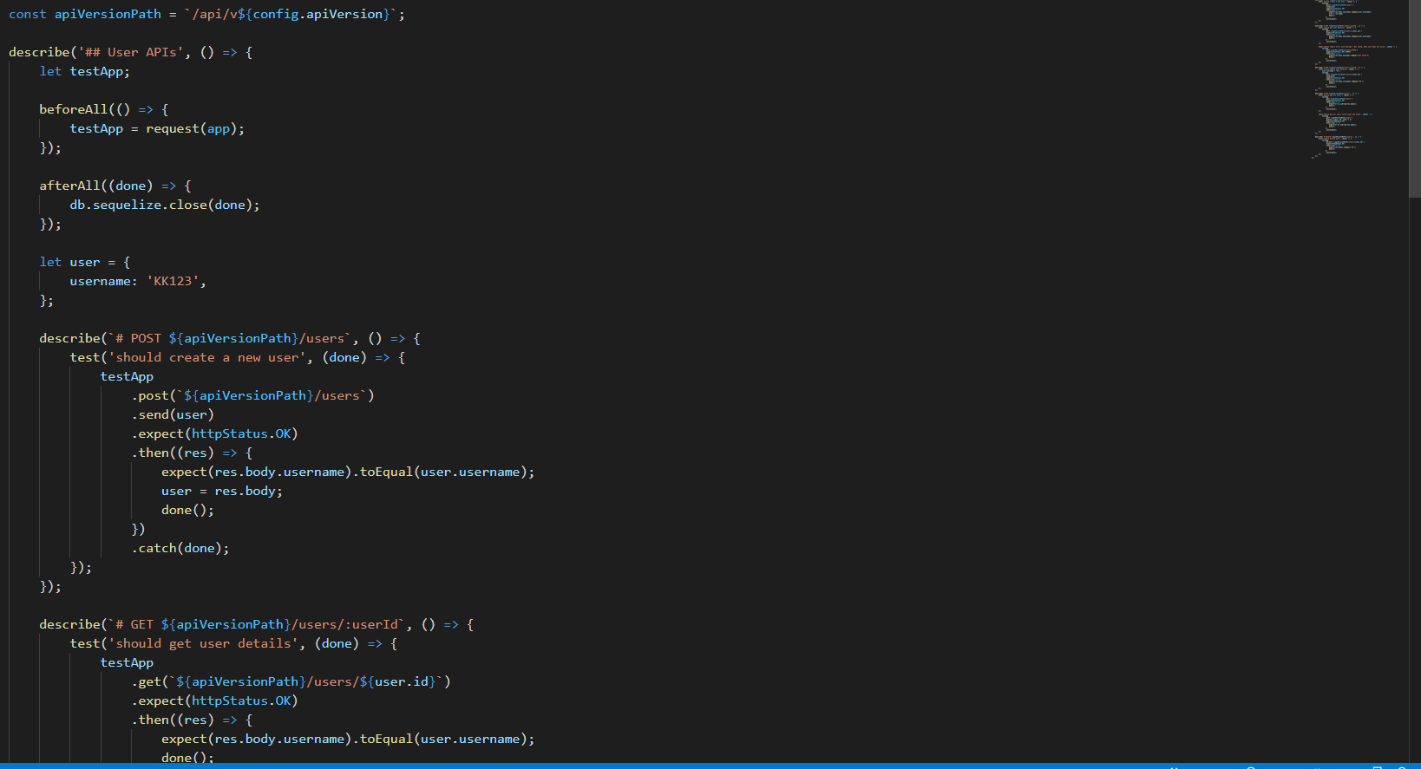

**# Regression Algorithms**

Regression algorithms are a popular algorithm under supervised machine learning algorithms. Regression algorithms can predict the output values based on input data points fed in the learning system.

The main application of regression algorithms includes predicting vegetables market price, predicting up down of prices, etc.

By this algorithm we can predict the prices of all vegetables and we can get good prices of our produces.

**10.2 Frontend Code**

This is the standard frontend code, followed throughout the modules in this project.

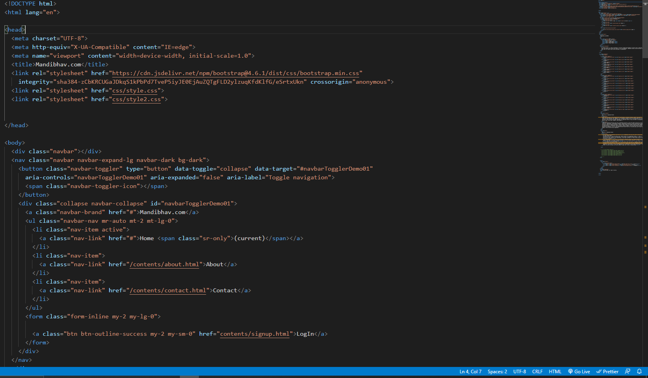

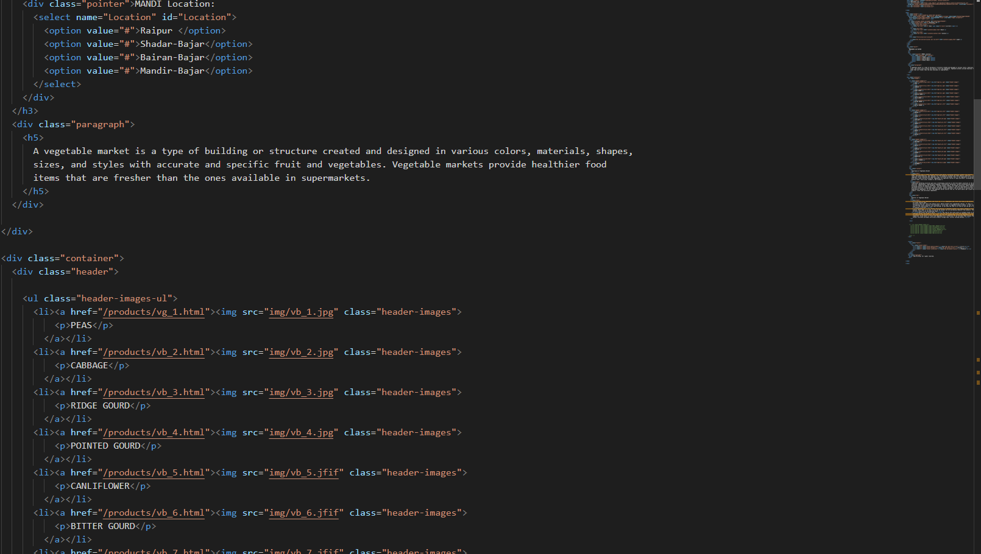

**Fig: code of index page**

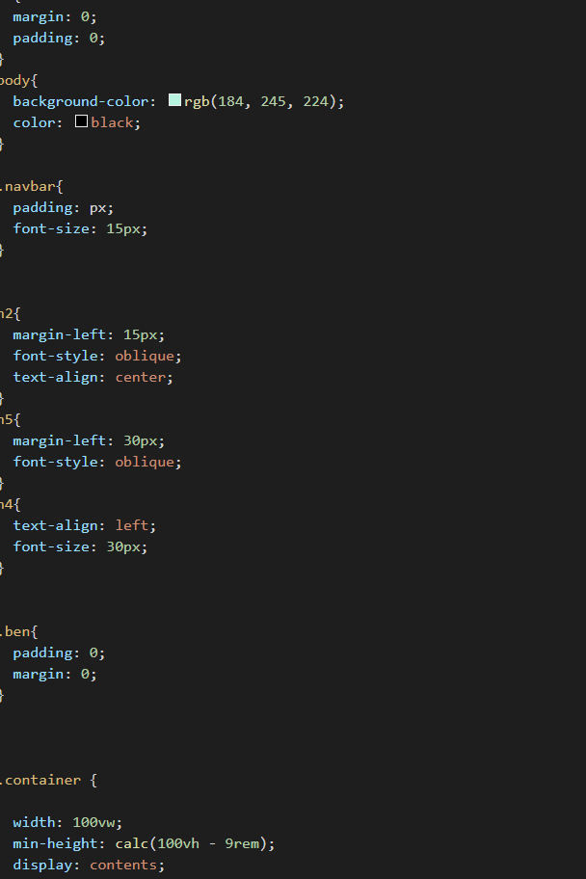

**Fig: CSS parts**

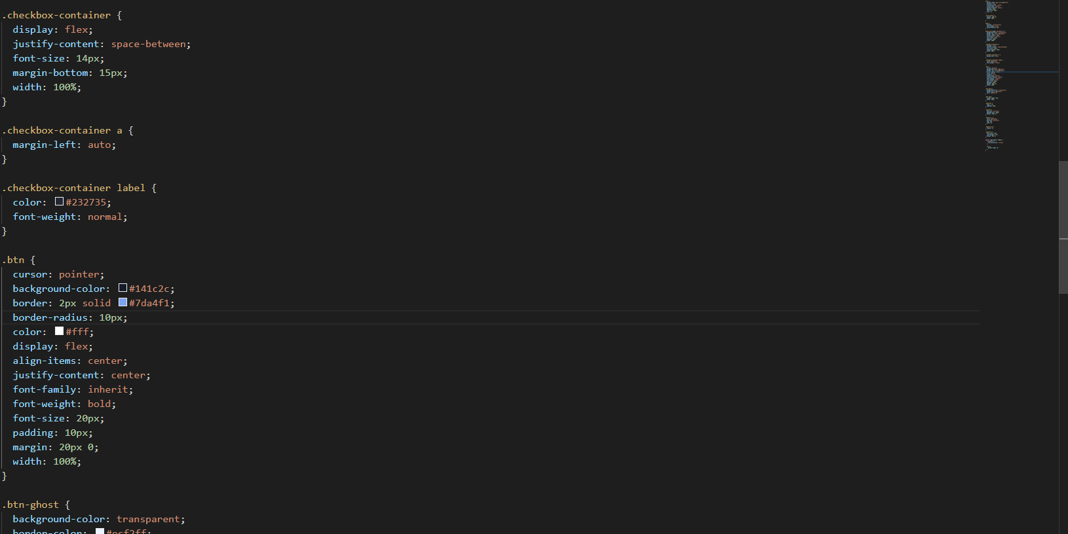

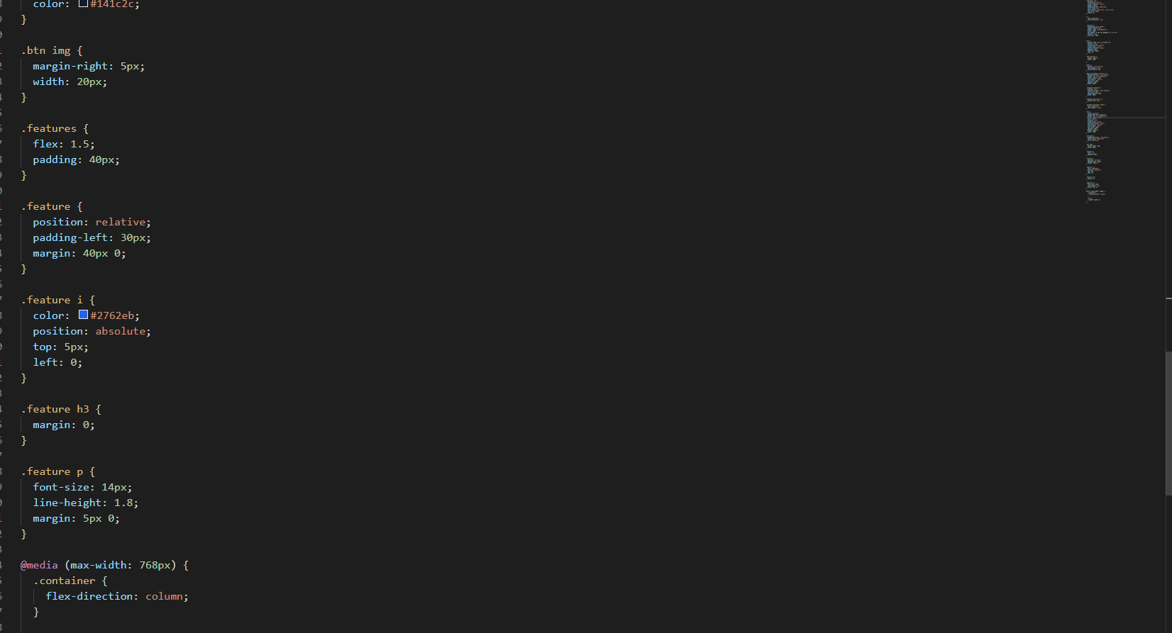

**Chapter 11**

**IMPLEMETATION AND MAINTENANCE**

**11.1 Implementation**

The project will be implemented in rural area. The admin panel will be provided to the Users. Through admin panel will start and arrange the vegetables and its prices. Rural people will see this site in their user panel. People will start to check market and vegetables details.

This project is built using Node js and MySQL, the implementation can be done on any node js supported server. The developer needs to code the node js pages with error free and optimized way, so that it would not cause the server related issue.

Developer needs to manage all the modules and interconnect them with each other. The requires once function is used to reuse any file on other file. The project is designed with the help of good understanding of programming languages used in this project. After the successfully coding and testing, the project will be deployed on live server.

The deployment will have two parts, one for database and other for files. First we will deploy the database inside the server and database connection credentials will be given by the server. This database connection credentials will help the js files to connect to the database. The connection credentials will be coded under the control module of admin subsystem and user subsystem.

Now the files will be uploaded to the root folder of the server, the root folder will be specified by the server control panel. If everything will be fine, the project will be start running smoothly.

**11.2 Maintenance**

Time to time or users reported modules will be timely updated. The function and modules will be changed over new plans or versions. New featured versions will be released after resolving any functions or user reported issues. It will use all three types of maintenance techniques:

**Corrective Maintenance:**

If any page or module causes bad effect to the other modules or the database, then codes will be supervised and changed. Required correction will be done in timely manner.

**Adaptive Maintenance:**

The changes in the functions and modules will be done for each phase of the new version. Programs will be changed and new programs will be added to the module.

**Chapter 12**

**TESTING**

Now we are in the testing phase, the project has been developed successfully till now. The project will now test on various parameters whether the project is producing good results in all aspects of the testing phase.

**Functionality Testing**

1. No dead pages and non reachable codes.

2. No non reachable pages and modules.

3. No any dead redirects urls.

4. Each necessary module and pages is connected to each other.

5. All pages have validation code for right user authentication.

6. All backend codes have field validation logics.

7. Invalid input will be discarded by the backend codes effectively.

8. Data are integrated with each other (Exa. user_id is connected to each order or card product).

9. Data flow is going right with the user requests.

**Usability Testing**

1. Contents used in the pages are describing right information.

2. There is perfect navigation for each page, which can direct user to positive direction.

1. Having all the important links to go through all the modules.

**Compatibility**

1. Project is compatible with most of the browser.

2. Supports most of the operating system.

3. Compatible with all screen size devices like desktop, laptop, tablet or mobile phones.

**Chapter 13**

**SYSTEM SECURITY MEASURES**

Security measures are the most important part of any project. System should be gone through the major security checks like non authorized access or data leak or invalid behavior etc. System should be able to handle these kinds of security attacks and secure itself with the help of developer directed paths.

**Security Checks**

* To prevent SQL injection the most secure functions has been used on each backend code containing pages.
* Each page has validation codes through which an unauthorized user cannot access the content of the page unless he has the right credentials according to the database.
* Password has been encrypted with the help of md5 and sha1 encryption methods.
* Having front end validation on each input fields.
* Will be timely updated the password encryption methods.

**Chapter 14**

**PERT CHART**

**Fig. 14.1 Pert chart of module completion**

The pert chart in fig. 14.1 shows the time taken and module interconnection of each module. Modules contain some files of codes; each module has been completed with several days and has some dependencies on other module. This pert chart will help to understand the project flow of development path.

**Note:**

* Circle indicates the modules.
* Numbers inside circle give idea about the order of the module development.
* Line shows interrelated dependencies of modules.
* Text above each circle indicates the number of days, used by that module to complete.

**Chapter 15**

**CONCLUSION AND FUTURE SCOPE**

**Conclusion**

Marketing is one of the most important factors in determining the success of any fruit and vegetable farming enterprise. Marketing includes all the operations and decisions made by producers. These decisions range from deter-mining the most marketable crops for production to deciding how to best deliver quality produce to the consumers at a profit. However, contrary to popular belief, marketing does not begin after a crop is produced. Instead, marketing alternatives need to be considered even before production takes place.

This webpage is providing exact information about vegetable market status to consumer and producer. That is provided a pricelist of vegetable that helps to former to get great price of by their produces. And that is help to development of former. We can also get a price list of vegetables and its consuming quantities of vegetables. With all data the of price and consuming we are predict the vegetables price. That is helps all people.

**Future Scope:**

It can be easily said that it is just a middle point of the e-commerce industries. There is a huge consumers on rural areas, if e-commerce industries can catch the requirements of the rural area people, then it will be milestone for them. Future study needs the wider understanding of rural people mindset towards online. Also need to test various techniques to motivate them for going online instead of limiting themselves in their area only. And also former get good price of their produces etc…

**Chapter 16**

**REFERNCES**

1. Department of Rural Development:

FOOD:-Agriculture and Formers Welfare. Consumer Affairs, Food and Public Distribution etc…

1. Dr. Rashmi Singh (2020). “Possibilities of E-Commerce in Rural Areas of the Harda District in Madya Pradesh”” *International Journal of Innovative Research in Technology and Science, Volume 8, Issue 2*
2. Anil Kumar S. Hagargi(2011).“Rural Market in India: Some Opportunities and Challenges” *International Journal of Exclusive Management Research*
3. JavaScript [Internet]. Mozilla.org. Available from:

https://devel- oper.mozilla.org/en-US/docs/Web/JavaScript

5. NodeJS Introduction [Internet]. Tutorialspoint.com Available from: https://[www.tutorialspoint.com/nodejs/nodejs_introduction.htm](http://www.tutorialspoint.com/nodejs/nodejs_introduction.htm)

6. NodeJS Introduction [Internet]. Tutorialspoint.com Available from: https://[www.tutorialspoint.com/nodejs/nodejs_introduction.htm](http://www.tutorialspoint.com/nodejs/nodejs_introduction.htm)

7. NodeJS use cases [Internet]. Credencys.com. Available from: https://www.cre- dencys.com/blog/node-js-development-use-cases/

8. MySQL DATABASE - Mysql.com. Available from https://docs.mysql.com/manual/introduction/

9. M Epuri, B Harichandana, TB Reddy (2019). “Customer Attitude towards Adopting E-Commerce in Rural India”.